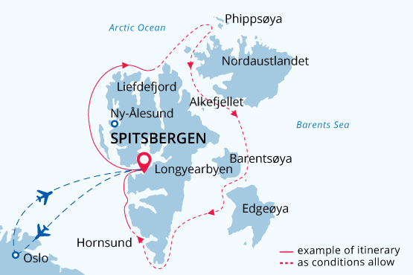

Svalbard & Polar Ice Edge
Svalbard Through the Camera Lens
25 Jun - 07 Jul 2024
13 days
Embarkation: Longyearbyen (Svalbard)
Disembarkation: Longyearbyen (Svalbard)
M/v Sea Spirit
Activities:

Itinerary
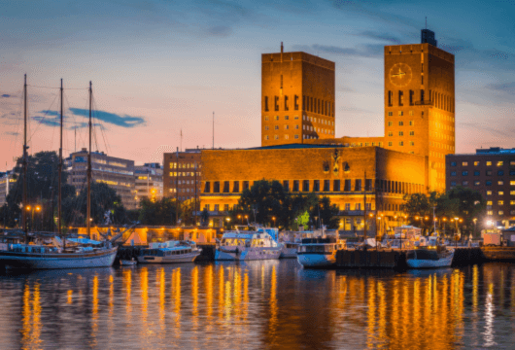Day 1 (June 25): Arrival to Oslo (hotel night)
Welcome to Oslo, which in 2019 was awarded the prestigious title “Green Capital of Europe”. We’ve arranged a comfortable stay for you at an Oslo Airport hotel so that you’re conveniently close for your flight to Longyearbyen on Day 2.
If you’re adventurous and have the time, take the handy airport train into central Oslo – it’s a 20-minute ride and trains depart and arrive frequently during the day. Near Oslo Central Station are shops, cafes, the Botanical Garden, cultural attractions and the attractive waterfront area.
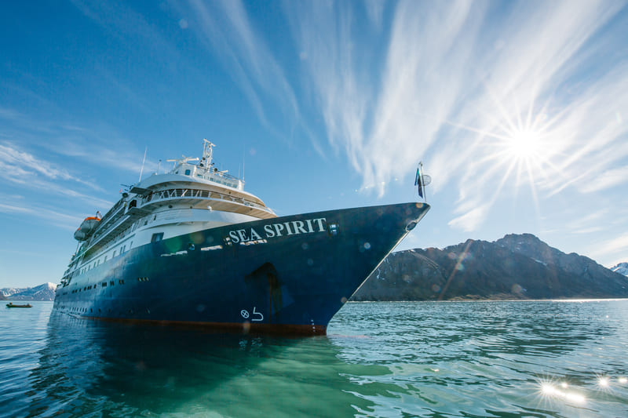Day 2 (June 26): Welcome Aboard!
Today you have a flight to Longyearbyen (regular airline flight), the administrative center of Svalbard and starting point of our Arctic expedition! At the Longyearbyen airport, you will be greeted by our staff and transferred to the pier where we will warmly welcome you aboard the deluxe expedition vessel M/V Sea Spirit. Get settled in your spacious suite and explore the ship that will be your comfortable home during the extraordinary adventure to come. Once underway, a full schedule of events kicks off with informative briefings and introductions from your expedition staff.
This is not just any cruise, but a photo cruise, designed specifically for amateur photographers of all skill levels. It will be a cool and unforgettable journey. You will have the opportunity to photograph some of the most pristine and remote wilderness areas in the world, and to develop your photography skills in the company of like-minded fellow travelers.
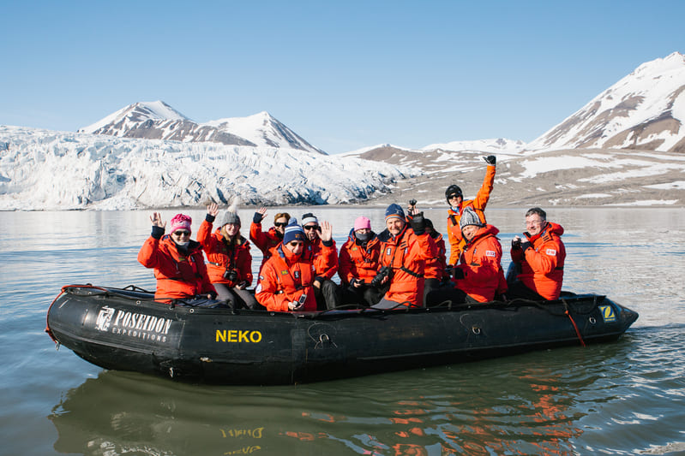Day 3-11 (June 27-July 5): Svalbard and Polar Ice Edge
The goal for this voyage is a circumnavigation of Spitsbergen, the largest island of the Svalbard archipelago. Along the way, we hope to experience the many facets of this incredible High Arctic territory. Our exact schedule and route will be shaped by weather and ice. During this mid-summer voyage, we hope ice conditions will be favorable for a circumnavigation, though we expect there will still be plenty of sea ice around to support ice-dependent animals such as polar bears and walrus. In addition to seeing Spitsbergen from every angle, this itinerary offers the appealing possibility of setting foot on all four of Svalbard’s main islands.
As you cruise along the coastline of Spitsbergen, you will have the opportunity to capture breathtaking images of snow-capped mountains, icy glaciers, and rugged coastlines.
The first of many pristine natural areas on this itinerary is South Spitsbergen National Park, a vast region of varied landscapes including polar deserts and impassible mountain ranges. The centerpiece of this park is Hornsund, a picture-perfect fjord where countless mighty glaciers cascade from soaring mountaintops into icy inlets. The park also includes the southern shores of Bellsund, a picturesque bay where we find the remains of historical whaling operations, including cabins, wooden boats and thousands of whale bones—a scene from the distant past, literally frozen in time. Throughout the park, there is always a high probability of wildlife sightings. There are also plenty of possibilities for world-class hiking through wild polar landscapes with fascinating geology. Wildflowers are especially abundant during this time.
Next along our route is the wildlife-rich Southeast Svalbard Nature Reserve, a pristine and rarely visited wilderness containing hundreds of uninhabited islands. On the large islands of Edgeøya and Barentsøya, we discover broad tundra valleys supporting the territory’s densest population of endemic Svalbard reindeer. We may see newborn reindeer calves at this time of year. The valleys are also important breeding areas for ground-nesting birds such a geese, eiders and sandpipers. Arctic foxes prowl the vast landscape, seeking to provide food for their growing cubs. Shallow, murky seas are ideal feeding grounds for walrus, which can be seen resting in large numbers on gently sloping beaches. Historical sites throughout the islands provide glimpses into the region’s bygone era of trapping and hunting.
During this voyage, we expect to encounter the densest concentrations of sea ice in the enormous Northwest Svalbard Nature Reserve. In this remote and isolated region, ice can persist very late into the summer, giving it a truly polar character. This reserve covers the rugged northwestern parts of Spitsbergen and the entirety of Nordaustlandet, the second largest island in Svalbard. Here we find the massive Austfonna ice cap, part of which meets the sea along the 45-kilometer ice cliff known as Bråsvellbreen—one of the great wonders of the Arctic world. The polar desert environment supports little in the way of vegetation but hosts prodigious numbers of seabirds at breeding sites such as the spectacular sea cliffs of Alkefjellet. The probability of encountering polar bears and walrus in this icy wilderness is very high.
At this time of year, the edge of the polar pack ice will likely be close to Nordaustlandet. We hope to sail along this dynamic boundary between sea and ice, where we have an unparalleled opportunity to witness the dramatic interplay between polar bears and seals. We will take the ship as close as safely possible to the jumbled and constantly shifting ice floes in the hope of observing polar bears in their preferred habitat.
Finally, we reach Northwest Spitsbergen National Park, the crown jewel of Svalbard’s scenic wonders. Here we find deep fjords flanked by serrated mountain ranges and immense tidewater glaciers calving icebergs into turquoise waters. During our voyage, the seabird breeding season is in full swing and the skies are filled with millions of murres, guillemots and little auks. This is also a great time to encounter marine mammals, including beluga whales and various Arctic seals. Set among this incredible scenery and wildlife activity, we also find evidence of Svalbard’s earliest sealers and whalers.
Human habitation along our route can be found at Ny Ålesund, a former mining town and airship base that is now home to an international community of Arctic researchers. This is one of the world’s most northerly settlements where we find a museum, gift shop and post office.
The ambitious Svalbard and Polar Ice Edge route offers a comprehensive view of the Arctic’s many faces. Every day offers something new and exciting. We will not miss a single opportunity to encounter amazing Arctic wildlife, to witness incredible polar scenery, and to walk in the footsteps of historic expeditions that came before.
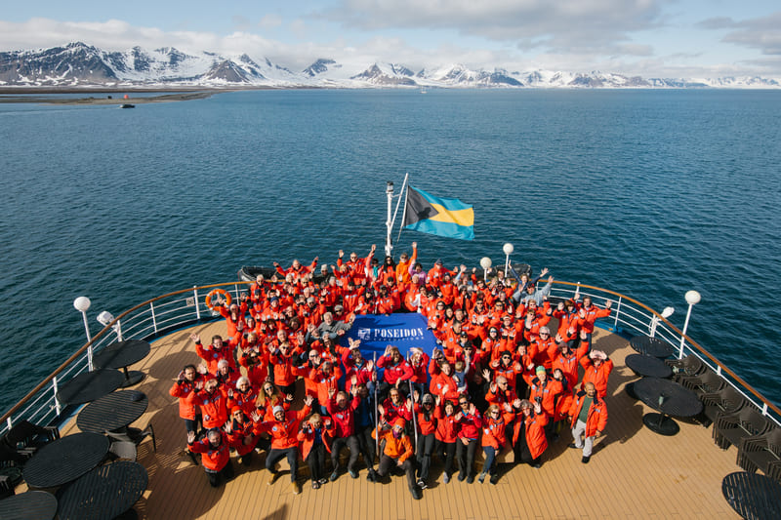Day 12 (July 6): Disembarkation in Longyearbyen, Svalbard
After our final breakfast aboard, we will disembark in Longyearbyen. However, the day promises further exploration in this charming town full of attractions. Right after disembarkation, you will be offered a guided sightseeing tour, which includes visits to the Svalbard Museum and the Art Gallery. In the evening, you can relax in a comfortable hotel in Longyearbyen.
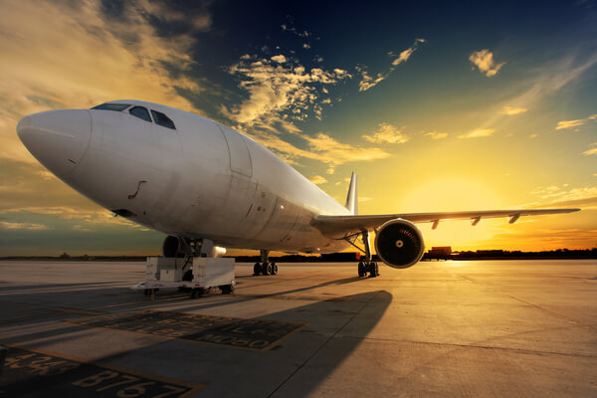Day 13 (July 7): Regular flight back to Oslo
Today marks the beginning of our journey back home. We will arrange your transfer to the airport, where a regular flight will transport you to Oslo. By now, you might already be dreaming up plans for your next polar adventure!

Special guest
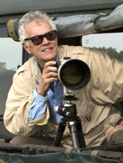Rick Sammon
Award-winning photographer
Rick started his professional photography career as an underwater photographer. He easily transitioned into travel, landscape, wildlife, cultural and nature photography. Rick’s images, from his travels to more than 100 countries, have been published in numerous newspapers and magazines, and have been featured in his 39 books. Rick will provide a photo workshop and be available for tips and advice – all with the objective of helping you capture the mood and feeling of the expedition. His wife Susan will also offer instructions on better smart phone photography.
Rick also teaches image processing on the ship, helping transform snapshots into great, memorable shots. In recognition of his talent and influence, Rick has been named a Canon Explorer of Light. Rick is also a Westcott Top Pro Elite. You might also catch Rick at the piano or with his guitar in the lounge!

M/v Sea Spirit
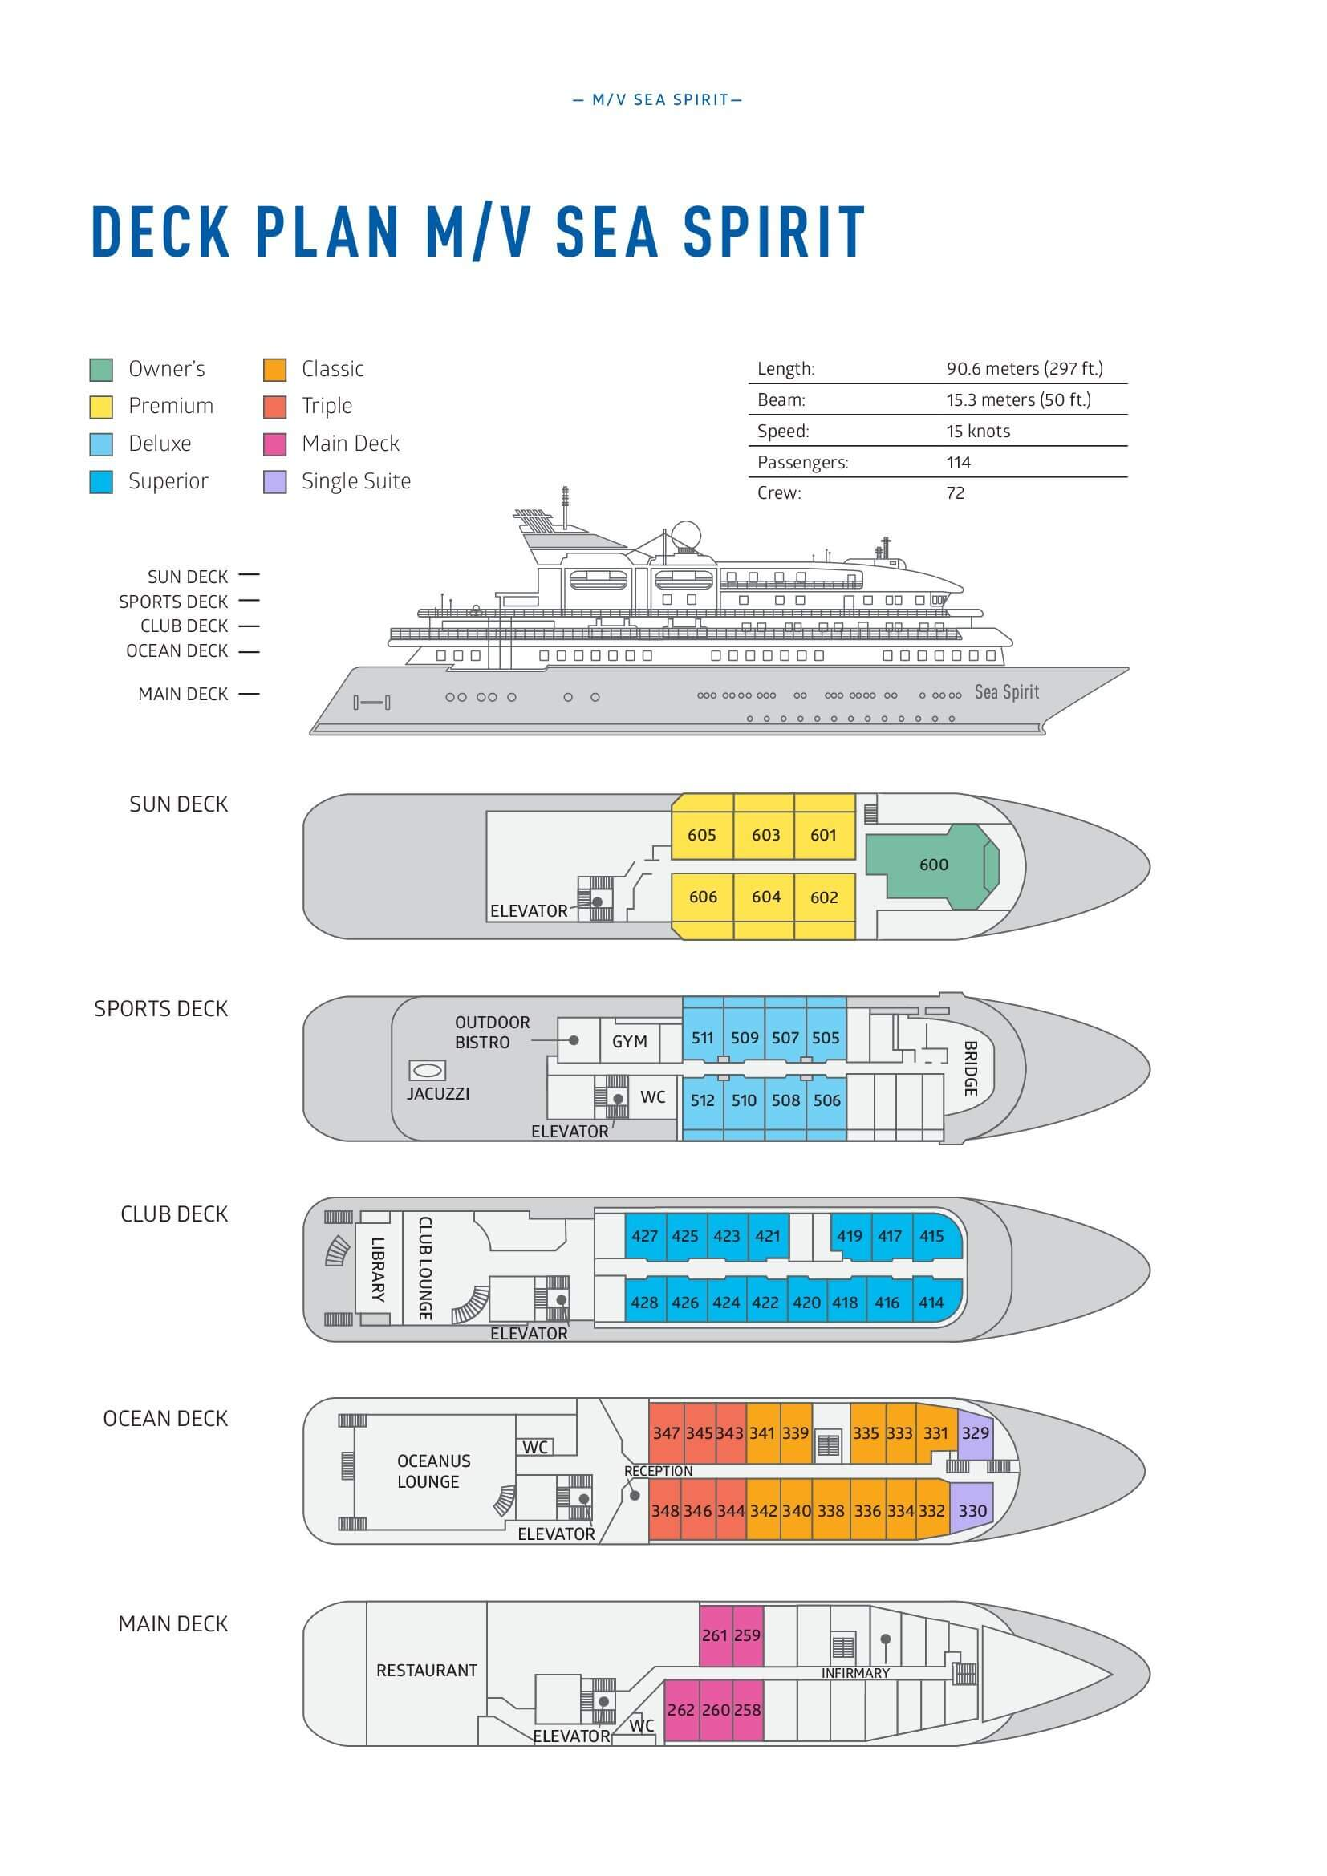

Triple Suite  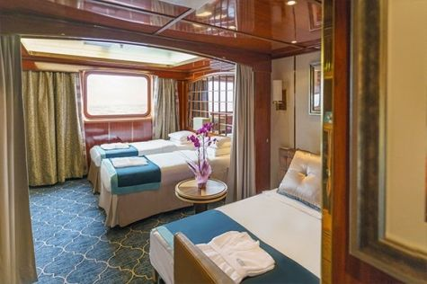  Averaging 21 square metres/226 square feet, these staterooms have two twins and a comfortable sofa bed. The twins also convert to a King, if desired. Located on Oceanus Deck, these suites have a picture window, two wardrobes and en suite facilities. Amenities include: in-room safe, refrigerator, satellite telephone access, TV/DVD, individual temperature control, and hair dryer. | Main Deck Suite  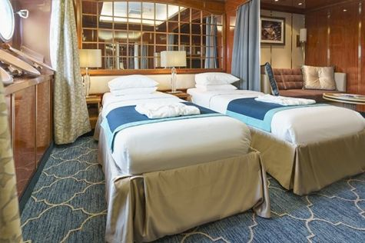  Averaging 23 square metres/248 square feet, Main Deck cabins are equipped with either two twins or a King Size bed. They are located on the Main Deck with a minimum of two portholes for exterior views. Amenities include: en suite facilities, in-room safe, refrigerator, satellite telephone access, TV/DVD individual temperature control and hair dryer.
Single Suite  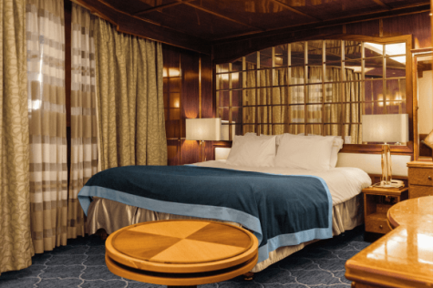  Averaging 21 square meters/226 square feet, these cabins are located on the Oceanus Deck. They feature a picture window (it may be covered during rough sea crossings), two wardrobes, and a King Size bed. Amenities include: en suite facilities, in-room safe, refrigerator, satellite telephone access, TV/VCR, individual temperature control, and hair dryer. | Classic Suite  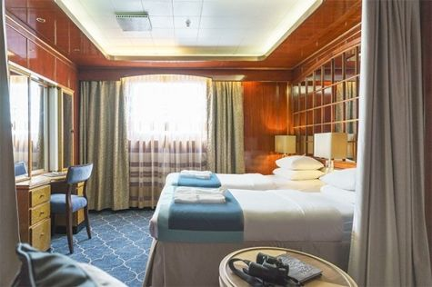  Averaging 21 square metres/226 square feet, these cabins are located on the Oceanus Deck. They feature a picture window, two wardrobes and a choice of either two twin beds or a King Size bed. Amenities include: en suite facilities, in-room safe, refrigerator, satellite telephone access, TV/DVD, individual temperature control and hair dryer.
Superior Suite  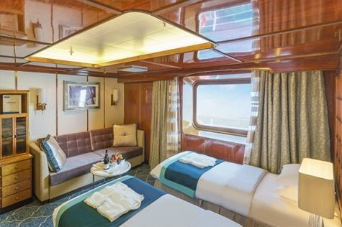  Superior Suites are located on the Club Deck. Averaging 20 square metres/ 215 square feet, these cabins feature two twin beds or a King Size bed. The picture window overlooks an outside walkway on the Club Deck. Amenities include: en suite facilities, walk-in closet or wardrobe, in-room safe, refrigerator, satellite telephone access, TV/DVD, individual temperature control, hair dryer. | Deluxe Suite  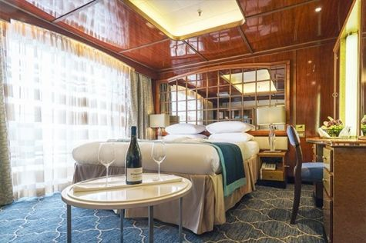  The Deluxe Suites with balconies are located on the Sports Deck. Averaging 24 square metres/ 258 square feet means plenty of room. Choose from either two twin beds or a King Size bed. A sliding glass door leads to a private balcony. These suites feature a walk-in closet or wardrobe. Amenities include en suite facilities, in-room safe, refrigerator, satellite telephone access, TV/DVD, individual temperature control, and a hair dryer.
Premium Suite  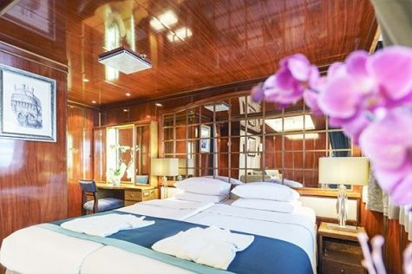  The Premium Suites are located on the Sun Deck. Averaging a generous 30 square metres/ 323 square feet, with two twin beds or a King Size bed. Access the private balcony by a sliding glass door. Amenities include: en suite facilities, lounge area, in-room safe, refrigerator, satellite telephone access, TV/DVD, individual temperature control, and hair dryer. | Owners Suite  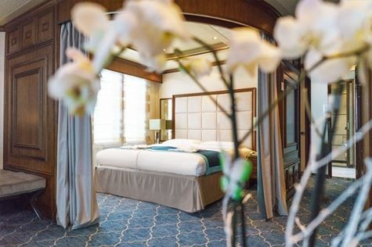  Super-spacious (63 square metres/ 678 square feet) elegant suite on the Sun Deck. Designed for entertaining, the Owner's Suite has a separate living room with game and meeting area. A BOSE stereo system provides background music, or watch videos on the HD plasma TV. Sliding glass doors lead to a private deck. Refresh in the jetted bathtub in en suite facilities. Slumber in the King Size bed. A sofa bed can accommodate a third person.

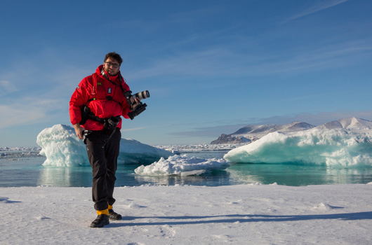 | Photography  What to expect on your photo tour  A polar cruise designed for photographers of all skill levels is a perfect way to experience the beauty and grandeur of the polar regions while also improving your photography skills.  - Watch breathtaking scenery and mesmerizing landscapes in one of the most remote places on Earth  - See the contrast of unique locations and their iconic wildlife  - Join our onboard photo workshops and get guidance from professional photographers  - Learn about the history and most significant spots in the area, and capture polar exploration history on your camera  - See an abundance of wildlife  - Discover the best wildlife viewing and photo ops with your expedition team and our onboard naturalists  - Scout the best locations on foot, on Zodiac excursions or while kayaking  - Our professional expedition team and experienced captain will maneuver and bring you safely to the places with the best photo ops

Rates
Triple Suite | Main Deck Suite | Single Suite | Classic Suite | Superior Suite | Deluxe Suite | Premium Suite | Owners Suite
US$ 9 595 | US$ 13 195 | US$ 19 495 | US$ 13 995 | US$ 14 295 | US$ 15 995 | US$ 17 495 | US$ 22 295

Cruise rates are quoted per person. Sharing is available in Triple, Main Deck, Classic, and Superior Suites. If you prefer a cabin for yourself, all cabin categories are available with the single supplement: x1.5.

Rates Include  1 pre-voyage hotel night on Day 1 in Oslo;  1 post-voyage hotel night on Day 12 in Longyearbyen;  A guided sightseeing tour upon disembarkation in Longyearbyen on Day 12;  Group transfer to the ship for embarkation on Day 2;  Shipboard accommodation;  All meals on board throughout the voyage;  AECO fees and governmental taxes.  Tea and coffee station 24 hours daily;  All scheduled landings/excursions (subject to weather and ice conditions);  Leadership throughout the voyage by our experienced Expedition Leader and Expedition Team;  Branded Poseidon Expeditions parka;  Rubber boots for shore landings for the time of the cruise;  Welcome and Farewell cocktails;  All port fees;  Group transfer to the airport on Day 13;  Pre-departure materials;  Digital Voyage Log;  Wi-Fi on board. | Rates Do Not Include  International Airfare;  Visa and passport fees (if applicable);  Luggage and trip cancellation insurance;  Soft drinks and alcoholic beverages other than those for special events and celebrations;  Fuel surcharge may be applied for all bookings;  Personal expenses such as laundry and telecommunication charges;  Mandatory Emergency Evacuation Insurance to a minimum benefit of US$ 200,000 per person;  Kayaking;  The cost of any applicable medical tests (such as COVID-19) or vaccinations required either by a national government or Poseidon Expeditions before, during or after the cruise;  Staff gratuities.
Itinerary, landings and all other activities during the cruise depend strongly on ice and weather conditions and are subject to the decisions of the Expedition Leader and the Captain of the vessel. Encounters with any mentioned wildlife cannot be guaranteed.

