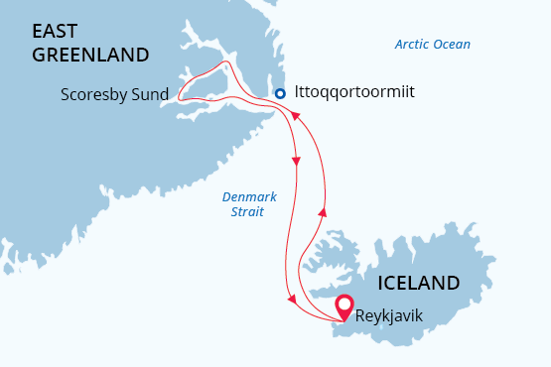

East Greenland
Arctic Sights and Northern Lights
01 Sep - 11 Sep 2024
11 days
Embarkation: Reykjavik (Iceland)
Disembarkation: Reykjavik (Iceland)
M/v Sea Spirit
Activities:

Itinerary
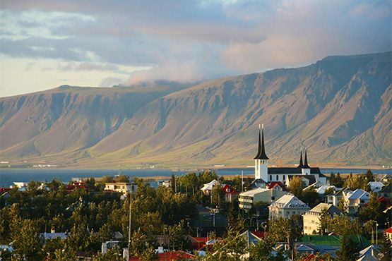Day 1 (Sept 1): Arrival in Reykjavík, Iceland (hotel night)
Welcome to Reykjavík, the capital of Iceland and starting point of our Arctic expedition! The drive from the Keflavik International Airport to the city center takes around 45 minutes by airport shuttle or taxi. After checking into your hotel, which has been arranged by us and is included in the price of the itinerary, you will be free to explore this attractive, friendly and quintessentially Nordic city.
For an excellent overview of Iceland’s history and culture, we recommend starting at the superb National Museum and Culture House. You will also want to visit the iconic Hallgrímskirkja church, Reykjavík’s most famous landmark. For those interested in natural history, we recommend the Whales of Iceland museum, which houses full-sized models of the 23 species of whale found around Iceland. For dinner, Reykjavík offers countless options for an authentic Icelandic meal.
Day 2 (Sept 2): Welcome Aboard!
After breakfast at your hotel, the morning is yours to enjoy Reykjavík. Take a leisurely stroll through a peaceful garden or a relaxing soak in a thermal bath. Nature lovers will appreciate the abundant birdlife at Tjörnin, a placid lake in the heart of the city. You can also take advantage of shopping for souvenirs or some last-minute necessities such as cold-weather gear. Just remember, you will soon receive your very own parka to keep and waterproof boots to borrow on board the ship.
In the afternoon, you will be transferred to the pier where we will warmly welcome you aboard the deluxe expedition vessel M/V Sea Spirit. Get settled in your spacious suite and explore the ship that will be your comfortable home during the extraordinary adventure to come. After getting underway, a full schedule of events kicks off with informative briefings and introductions from your expedition staff. After the first of many delicious dinners on board, step out onto the open decks to admire the views as we sail through Faxaflói, where it is possible to encounter our first whales.
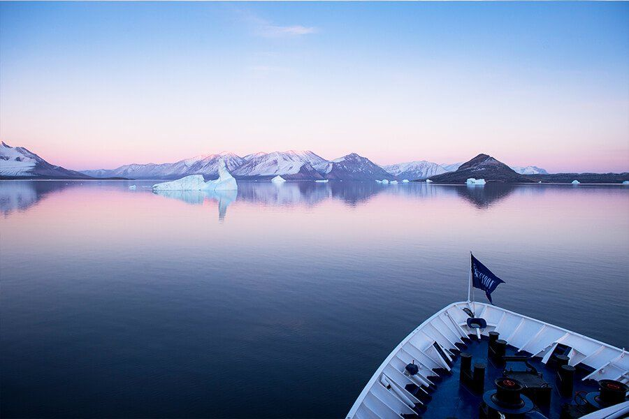Day 3 (Sept 3): Across Denmark Strait
As we sail north across the Denmark Strait to East Greenland, we celebrate our crossing of the Arctic Circle. We keep a continuous lookout for great whales and flocks of seabirds feeding in the productive waters near the sharp rise of Greenland’s continental shelf. After nightfall, we have our first of many opportunities to see the aurora borealis overhead.
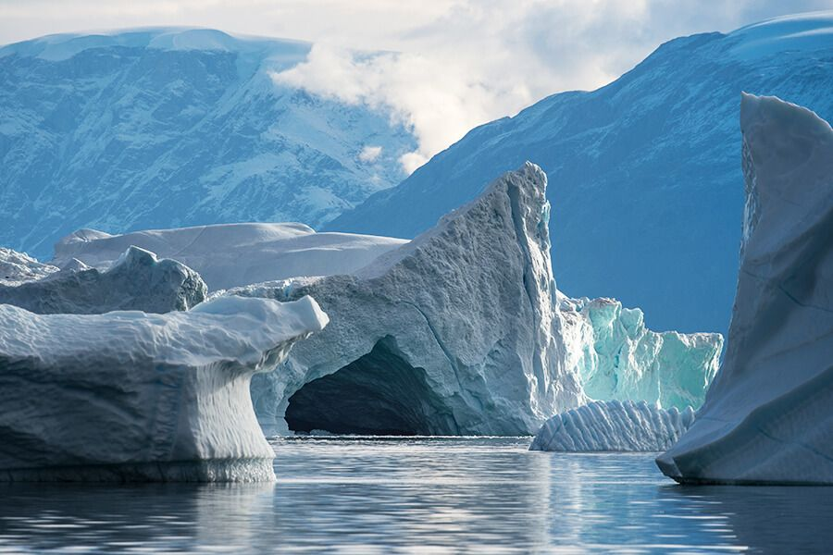Day 4-8 (Sept 4-8): Scoresby Sund, East Greenland
The itinerary for this part of our voyage focuses on the spectacular fjords, coasts and islands of Scoresby Sund, also known as Kangertittivaq in the Greenlandic language. This area contains some of the world’s most impressive scenery and Greenland’s best wildlife viewing. As with any true polar expedition, our exact schedule and route will be shaped by weather and ice. At this late stage of the season, we expect our explorations will be minimally affected by sea ice. However, we will be alert for icebergs from surging glaciers, which can present interesting navigational challenges. Our experienced captain and expedition leader will continually adjust plans as conditions and opportunities warrant in this wild and remote corner of the Arctic.
Scoresby Sund is one of the longest and most visually stunning fjord systems in the world. Almost totally devoid of human habitation, it is also one of the most pristine natural environments on Earth. In this epic wilderness, the forces of nature have shaped a landscape of incomparable grandeur. Deep fjords and narrow passages are framed by sheer rock walls up to 2,000 meters high. Colossal icebergs—calved by immense glaciers and sculpted by wind and water into fantastic shapes—drift throughout the intricate fjord system in striking contrast to sparkling blue waters and polychromatic mountains capped with fresh snow. From verdant coastal plains to ice-clad peaks all the way to the glaciated heart of Greenland, a trip through Scoresby Sund sets a new standard for “scenic”.
Our area of exploration includes part of Northeast Greenland National Park, the largest and most northerly national park in the world. This vast Arctic landscape is a paradise for hikers who appreciate astounding views of untouched tundra wilderness. Across hillsides emblazoned with autumnal red and yellow, a flash of white reveals the flight of a snowy owl or a startled mountain hare. Tufts of the finest fleece ensnared in polar willows underfoot point the way to a nearby herd of shaggy musk oxen. You may hear the crack of horns colliding as bulls engage in fearsome battles of strength. Boreal fowl of every description are preparing to migrate south with their newly fledged chicks. All throughout the waterways of Scoresby Sund, we are on constant watch for polar bears and other marine mammals, including a variety of seals, walrus and narwhal, which can be spotted at any time.
Ancient Thule archeological sites remind us of humankind’s age-old relationship with this austere yet life-sustaining environment. For a look at how this tradition has been carried forward, we plan to visit the modern Inuit village of Ittoqqortoormiit, the only permanent settlement in the region and one of the most remote communities in the world. The village boasts a wonderful museum, a bookstore, handmade crafts for sale, a post office, and an abundance of Greenlandic sled dogs.
In September, at the equinox, day and night are given equal opportunities to astound you. As night falls, the darkening sky becomes a stage for nature’s greatest celestial performance: the Northern Lights. East Greenland is one of the very best places in the Arctic to view this otherworldly natural phenomenon. In addition to being at the perfect latitude for strong aurora displays, the skies above Scoresby Sund are often cleared by katabatic winds rolling down from the nearby Greenland Ice Sheet. Lights dancing from horizon to horizon are mirrored in calm waters while the silhouettes of gigantic icebergs and serrated mountains add to the romantic splendor of the experience.
This itinerary offers a deep dive into one of the Arctic’s most scenic and soulful environments. From dawn to dusk and beyond, your days will be filled with incredible shore excursions, world-class Zodiac cruising, and enough stunning scenery to fill your camera and overwhelm your emotions. Hikers will live their wilderness dreams and sea kayakers will be rewarded with some of the finest paddling on the planet.
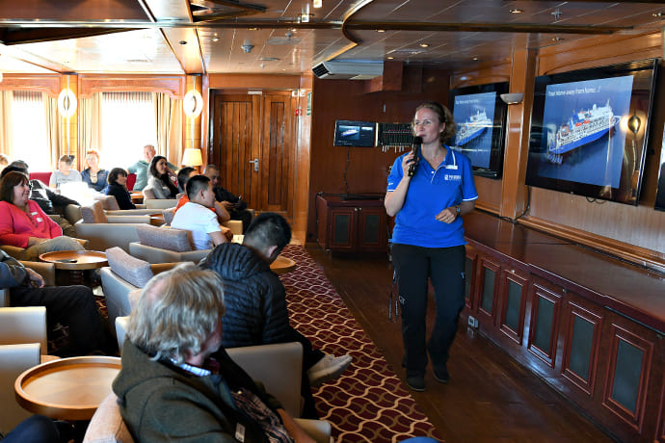Day 9 (Sept 9): Back to Iceland
After our amazing time in Scoresby Sund, we head back across the Denmark Strait toward Iceland. Presentations and workshops by our expert staff, as well as our range of onboard recreation facilities, ensure that this day at sea is not idly spent. Seabird viewing and whale sightings can be enjoyed from panoramic open decks and balconies.
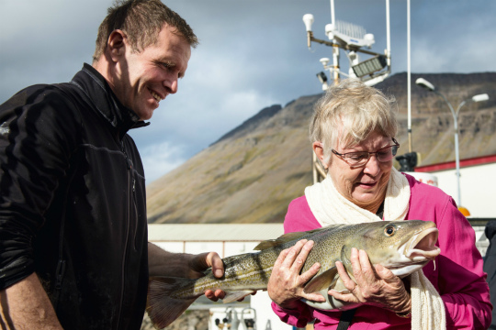Day 10 (Sept 10): Westfjords, Iceland
Our last expedition day is spent in the beautiful Vestfirðir (Westfjords) of Iceland. This remote and sparsely populated region of crenulated coastlines, voluminous waterfalls and rugged mountains sees only 10% of Iceland’s visitors. Deep fjords are home to whales while estuaries abound with seals and birdlife.
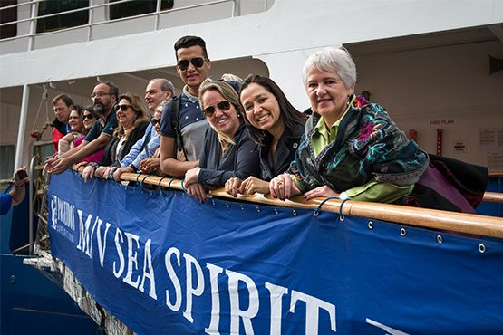Day 11 (Sept 11): Disembarkation in Reykjavík, Iceland
After filling up with one last buffet breakfast on board, we bid you a fond farewell in Reykjavík. We provide transfers to Keflavik international airport or to the city center in case you plan to extend your stay in Iceland.

M/v Sea Spirit
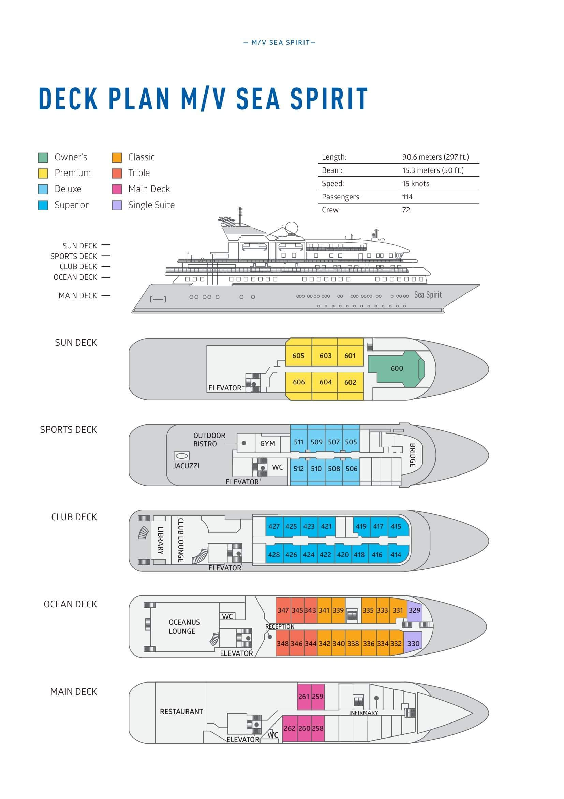

Triple Suite  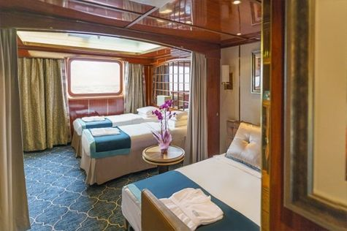  Averaging 21 square metres/226 square feet, these staterooms have two twins and a comfortable sofa bed. The twins also convert to a King, if desired. Located on Oceanus Deck, these suites have a picture window, two wardrobes and en suite facilities. Amenities include: in-room safe, refrigerator, satellite telephone access, TV/DVD, individual temperature control, and hair dryer. | Main Deck Suite  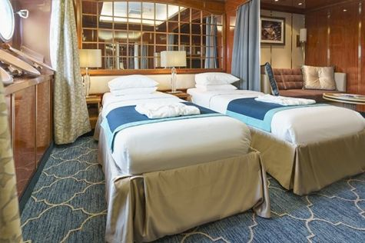  Averaging 23 square metres/248 square feet, Main Deck cabins are equipped with either two twins or a King Size bed. They are located on the Main Deck with a minimum of two portholes for exterior views. Amenities include: en suite facilities, in-room safe, refrigerator, satellite telephone access, TV/DVD individual temperature control and hair dryer.
Single Suite  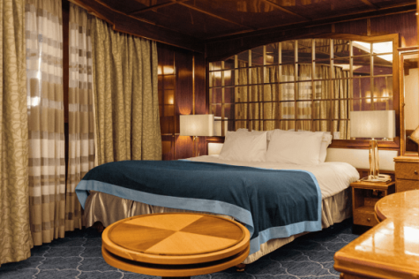  Averaging 21 square meters/226 square feet, these cabins are located on the Oceanus Deck. They feature a picture window (it may be covered during rough sea crossings), two wardrobes, and a King Size bed. Amenities include: en suite facilities, in-room safe, refrigerator, satellite telephone access, TV/VCR, individual temperature control, and hair dryer. | Classic Suite  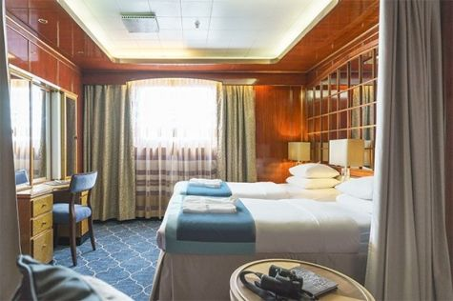  Averaging 21 square metres/226 square feet, these cabins are located on the Oceanus Deck. They feature a picture window, two wardrobes and a choice of either two twin beds or a King Size bed. Amenities include: en suite facilities, in-room safe, refrigerator, satellite telephone access, TV/DVD, individual temperature control and hair dryer.
Superior Suite  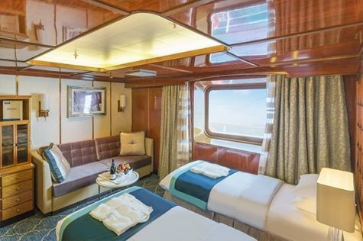  Superior Suites are located on the Club Deck. Averaging 20 square metres/ 215 square feet, these cabins feature two twin beds or a King Size bed. The picture window overlooks an outside walkway on the Club Deck. Amenities include: en suite facilities, walk-in closet or wardrobe, in-room safe, refrigerator, satellite telephone access, TV/DVD, individual temperature control, hair dryer. | Deluxe Suite  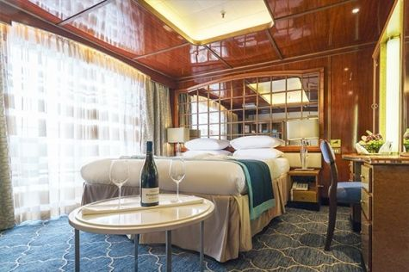  The Deluxe Suites with balconies are located on the Sports Deck. Averaging 24 square metres/ 258 square feet means plenty of room. Choose from either two twin beds or a King Size bed. A sliding glass door leads to a private balcony. These suites feature a walk-in closet or wardrobe. Amenities include en suite facilities, in-room safe, refrigerator, satellite telephone access, TV/DVD, individual temperature control, and a hair dryer.
Premium Suite  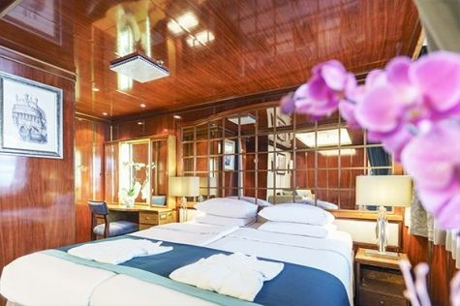  The Premium Suites are located on the Sun Deck. Averaging a generous 30 square metres/ 323 square feet, with two twin beds or a King Size bed. Access the private balcony by a sliding glass door. Amenities include: en suite facilities, lounge area, in-room safe, refrigerator, satellite telephone access, TV/DVD, individual temperature control, and hair dryer. | Owners Suite  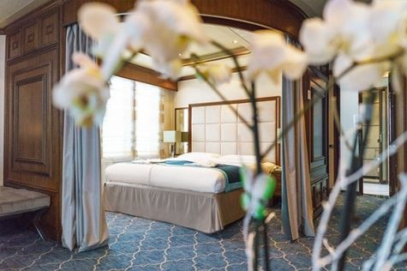  Super-spacious (63 square metres/ 678 square feet) elegant suite on the Sun Deck. Designed for entertaining, the Owner's Suite has a separate living room with game and meeting area. A BOSE stereo system provides background music, or watch videos on the HD plasma TV. Sliding glass doors lead to a private deck. Refresh in the jetted bathtub in en suite facilities. Slumber in the King Size bed. A sofa bed can accommodate a third person.

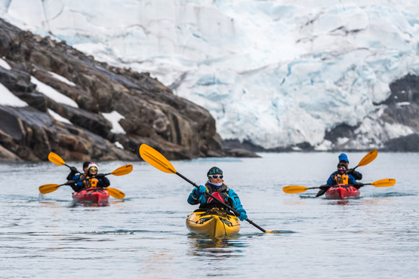 | Sea Kayaking  Kayaking fee $655 - A$885 - £505 - €625  Sea Kayak Club is typically offered on voyages that include High Arctic destinations such as Greenland, Svalbard (Spitsbergen), Franz Josef Land, or a combination of these thrilling places. Experience calving glaciers in Svalbard, cathedral-like icebergs in Greenland, or labyrinthine expanses of sea ice in the Arctic Ocean, all from our sturdy and stealthy sea kayaks. Join us for an unscripted kayaking adventure as we explore rugged coastlines and remote waters that very few people have ever paddled.
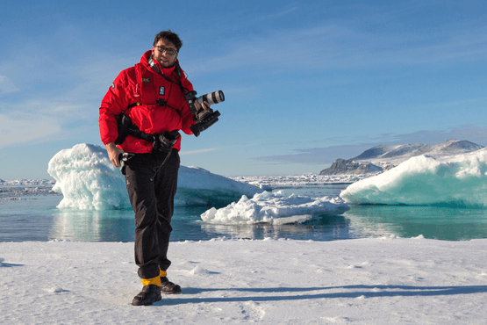 | Photography  Free option  The Polar Regions are perhaps the most photogenic on earth, with countless beautiful scenes presenting themselves every day. Endless expanses of ice, beaches crowded with seals or penguins, sunsets over unbroken horizons, starlit skies, and even the majestic northern lights – they all present fantastic photographic opportunities – and in order to make sure that you come home with some spectacular images we offer you the chance to learn and practice your photography alongside an experienced professional.  Our expert Photographer will be on hand to answer your questions and give advice, both in the form of on-board lectures and workshops on shore. Explore the key elements of photography in a fun and relaxed setting, with plenty of opportunities for questions and feedback. Learn how to see light in a new way and experiment with the techniques of composition and framing.

Rates
Triple Suite | Main Deck Suite | Single Suite | Classic Suite | Superior Suite | Deluxe Suite | Premium Suite | Owners Suite
US$ 7 095 | US$ 9 895 | US$ 14 695 | US$ 10 495 | US$ 10 695 | US$ 12 095 | US$ 13 195 | US$ 16 895

Cruise rates are quoted per person. Sharing is available in Triple, Main Deck, Classic, and Superior Suites. If you prefer a cabin for yourself, the following categories are available with the single supplement: x1.7 for Main Deck, Classic, and Superior Suites; x2 for Deluxe, Premium, and Owner's Suite.

Rates Include  1 pre-voyage hotel night on Day 1  Group transfer to the ship for embarkation on Day 2;  Shipboard accommodation;  All meals on board throughout the voyage;  AECO fees and governmental taxes.  Tea and coffee station 24 hours daily;  All scheduled landings/excursions (subject to weather and ice conditions);  Leadership throughout the voyage by our experienced Expedition Leader and Expedition Team;  Branded Poseidon Expeditions parka;  Rubber boots for shore landings for the time of the cruise;  Welcome and Farewell cocktails;  All port fees;  Group transfer to Keflavik International Airport (KEF) or centrally located hotel for luggage storage right after disembarkation;  Pre-departure materials;  Digital Voyage Log;  Wi-Fi on board. | Rates Do Not Include  Airfare;  Transfers from the airport to the hotel at beginning of the program;  Visa and passport fees (if applicable);  Luggage and trip cancellation insurance;  Soft drinks and alcoholic beverages other than those for special events and celebrations;  Personal expenses such as laundry and telecommunication charges;  Fuel surcharge may be applied for all bookings;  Mandatory Emergency Evacuation Insurance to a minimum benefit of US$ 200,000 per person;  Kayaking;  The cost of any applicable medical tests (such as COVID-19) or vaccinations required either by a national government or Poseidon Expeditions before, during or after the cruise;  Staff gratuities.
Itinerary, landings and all other activities during the cruise depend strongly on ice and weather conditions and are subject to the decisions of the Expedition Leader and the Captain of the vessel. Encounters with any mentioned wildlife cannot be guaranteed.

