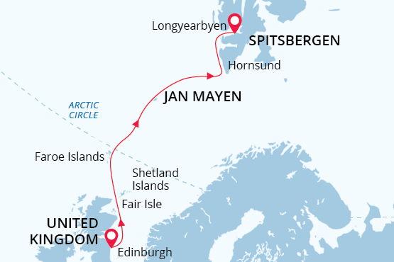

British Isles, Jan Mayen & Svalbard
Crossing the Arctic Circle
27 May - 08 Jun 2025
13 days
Embarkation: Edinburgh (Scotland)
Disembarkation: Longyearbyen (Svalbard)
M/v Sea Spirit
Activities:

Itinerary
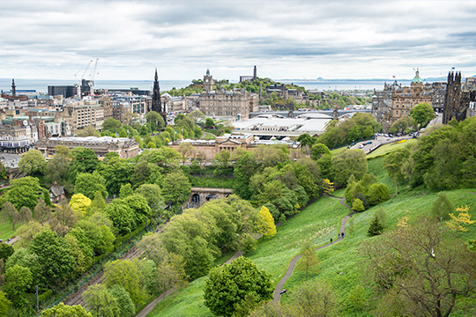Day 1 (May 27): Arrival in Edinburgh, Scotland (hotel night)
Welcome to Edinburgh, the capital of Scotland and starting point of our expedition. To provide you with more time to enjoy this metropolis rich in history and culture, we’ve arranged pre-cruise hotel accommodations. Relax and take a stroll through town, enjoying both medieval and classic 18th-century architecture. The famous Edinburgh Castle rises majestically above it all.
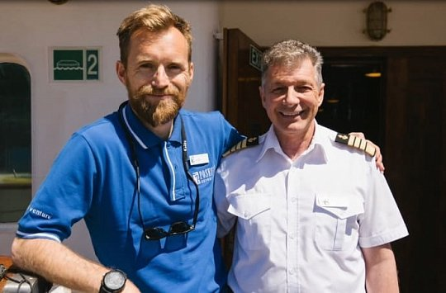Day 2 (May 28): Welcome Aboard!
Enjoy the morning and early afternoon at leisure. Each corner of Edinburgh’s old streets opens beautiful unexpected vistas of green hills or a blue flash of the distant sea. In the afternoon, you will be transferred from the hotel to the ship in the nearby Port of Leith. Before dinner, there’s time to explore the Sea Spirit, your home-away-from home for the next days.
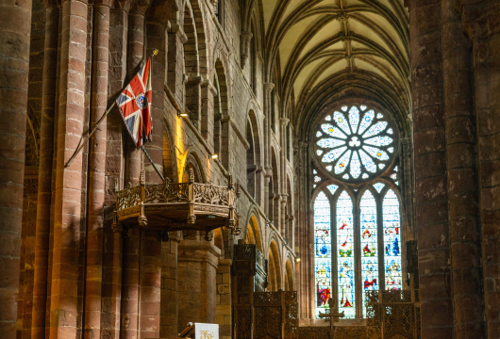Day 3 (May 29): Kirkwall, Orkney Islands, Scotland
Kirkwall is a small, quiet town, with a gentle pace of life. The town is the capital of the remote and amazing Orkney archipelago. Kirkwall is first mentioned in Orkneyinga saga in 1046. Such a long history has left a rich heritage that we explore today. The most famous are the sandstone St Magnus Cathedral, considered the finest medieval building in the north of Scotland, the Bishop’s Palace and the Earl’s Palace. Included tour “Ancient treasures of Orkney with St Magnus Cathedral.” Depart Kirkwall and head into the west of Mainland, Orkney’s largest island. This tour passes through the gentle rolling landscape of Orkney and into the Neolithic Heartland of Orkney; an area designated as a World Heritage Site due to its wealth of pre-historic archaeology. Passing the Standing Stones of Stenness, we will stop at the Ring of Brodgar; a huge ceremonial circle of stones dating back almost 5000 years. We then continue on to the 5000-year-old village of Skara Brae, beautifully interpreted in the visitor centre. See the remarkable dwellings revealed from beneath the sand dunes by storms only 150 years ago. Hear some of the stories from your guide today en route back to Kirkwall. Once back in the island capital we will take a tour of St Magnus Cathedral, built by the Vikings during their 500 year reign over the islands.
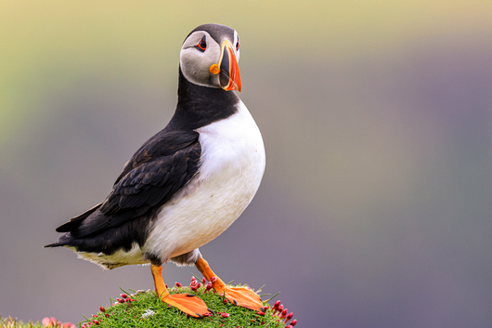Day 4 (May 30): Fair Isle, Shetland Islands
Fair Isle is a real paradise for birdwatchers. Huge number of birds inhabits the lush grasslands and spectacular cliffs. Over 345 species have been recorded here – more than anywhere else in Britain. During our walk across the island, we hope to see northern fulmars, kittiwakes, northern gannets, puffins, and great and arctic skuas.
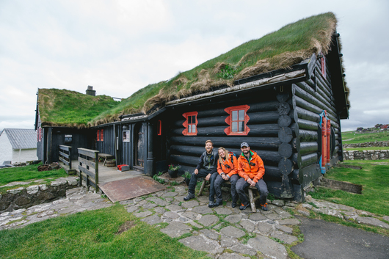Day 5 (May 31): Torshavn, Faroe Islands
National Geographic Traveler had designated Faroe Islands as “authentic, unspoiled and likely to remain so”. It seems that the Nature spares no colours in “painting” the islands. Deep-green hills, bright blue sea, colourful houses and boats, orange-red puffins’ beaks make the sceneries unforgettable, meanwhile traditional wooden dwellings with turf roofs look like they belong in a fairy tale.
The rugged Faroese are proud of their Viking heritage and their love of the sea. Today we will explore Tórshavn, the capital and largest city of Faroe Islands.
Tórshavn is a unique city, where history meets modernity, where picturesque old turfed houses and modern buildings stand side by side...
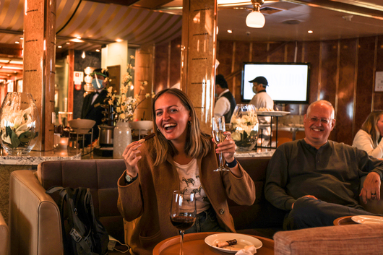Day 6 (June 1):­ At sea
Presentations and workshops by our expert staff, as well as our range of onboard recreation facilities, ensure that this day at sea is not idly spent. Seabird viewing and whale sightings can be enjoyed from panoramic open decks as well as exterior stateroom windows and balconies.
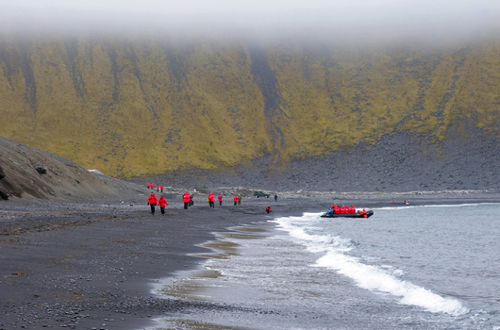Day 7 (June 2): Jan Mayen
Jan Mayen hosts the landscapes of breathtaking beauty and northernmost subaerial active volcano on the planet – the Beerenberg. The island is wild and uninhabited not including members of Norwegian weather station. The signboard at the entrance door says (translated from the Norwegian): “Theory is when you understand everything but nothing works. Practice is when everything works but nobody understands why. On this station, we combine theory and practice in a way that nothing works and nobody understands why”. Northern fulmars, Kittiwakes, and Brünich’s guillemots breeding on steep cliffs and slopes represent the birdlife of Jan Mayen.
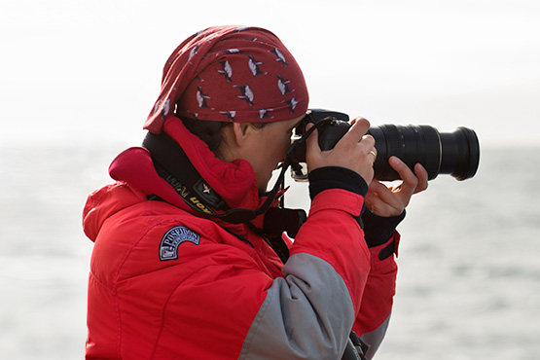Day 8 (June 3): At Sea
The lectures of our invited speakers prepare us for meeting with the unique Arctic wildlife and awesome landscapes of Svalbard.
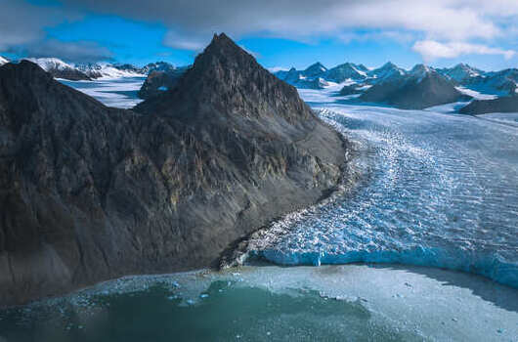Day 9-12 (June 4 - June 7): Exploring Svalbard
This is a real expedition in a true High Arctic wilderness. As such, our route and exploration opportunities here are heavily dependent on the weather and sea ice conditions we encounter. Our experienced captain and expedition leader decide the itinerary and continually adjust plans as conditions and opportunities warrant. You can be sure that the best possible advantage will be taken of the circumstances presented to us by Nature in this wild and remote corner of the Arctic. Polar bears and other quintessential Arctic wildlife can be spotted anytime, anywhere in and around Svalbard. We exploit every opportunity to experience excellent wildlife viewing, to discover incredible scenery, and to walk in the footsteps of the historic polar expeditions that came before us. We anticipate exploring the spectacular fjords, coasts, and islands in the western part of Svalbard. This area contains the archipelago’s most impressive scenery and some of the Arctic’s best wildlife viewing opportunities. Deep fjords and narrow channels are flanked by jagged snowy mountain peaks. Immense tidewater glaciers calve icebergs into turquoise waters. Fields of flowering tundra are home to grazing reindeer and playful Arctic fox. Bountiful inshore and offshore waters are home to walrus and a wide variety of whales. The whole area is alive with migratory birds, including numerous rare species, taking advantage of summer’s fecundity in 24-hour daylight. To complete the Arctic experience we also explore places rich with history. Our area of exploration contains the historical remnants of whaling camps, coal mining operations, trappers’ cabins, staging areas for historic attempts to discover the North Pole, and even an abandoned polar research station. The days are filled with memorable excursions, sumptuous meals, presentations by our experts, and enough stunning scenery and wildlife to fill your camera and overwhelm your emotions.
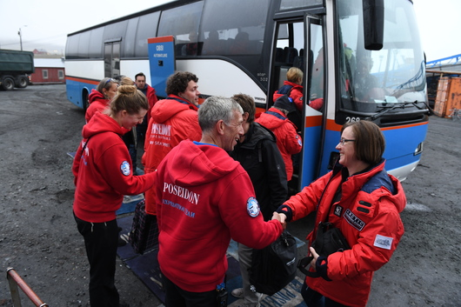Day 13 (June 8): Disembarkation in Longyearbyen, Svalbard
After filling up with one last buffet breakfast on board, we bid you farewell in Longyearbyen. We provide transfers to the airport or to the town center in case you plan to stay longer in Svalbard. By this time, you may already be making plans for your next amazing trip with us into the polar worlds!

M/v Sea Spirit
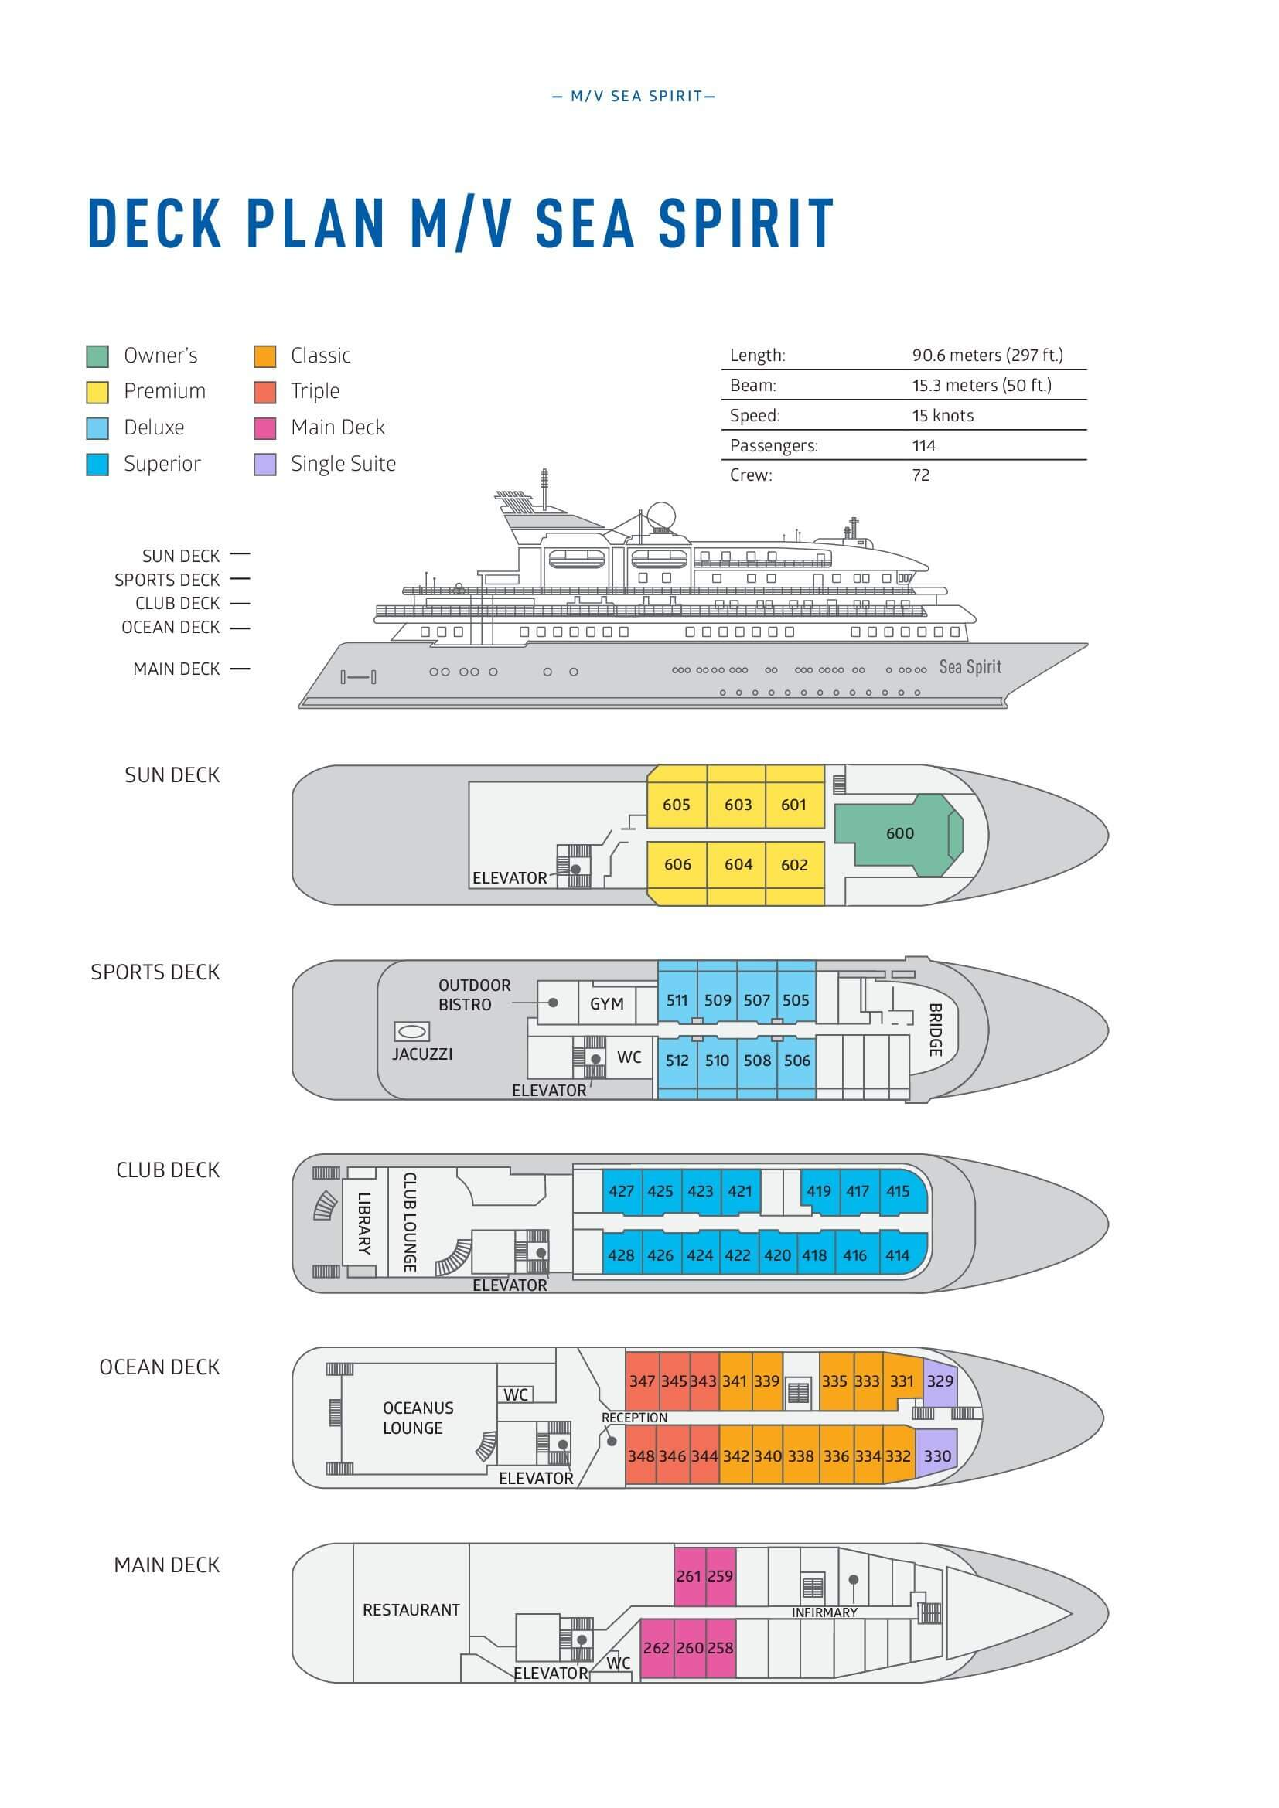

Triple Suite  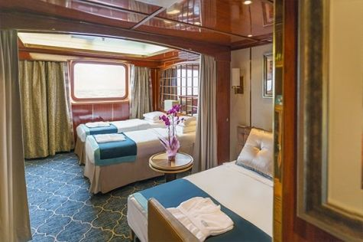  Averaging 21 square metres/226 square feet, these staterooms have two twins and a comfortable sofa bed. The twins also convert to a King, if desired. Located on Oceanus Deck, these suites have a picture window, two wardrobes and en suite facilities. Amenities include: in-room safe, refrigerator, satellite telephone access, TV/DVD, individual temperature control, and hair dryer. | Main Deck Suite  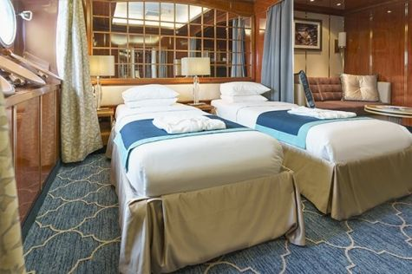  Averaging 23 square metres/248 square feet, Main Deck cabins are equipped with either two twins or a King Size bed. They are located on the Main Deck with a minimum of two portholes for exterior views. Amenities include: en suite facilities, in-room safe, refrigerator, satellite telephone access, TV/DVD individual temperature control and hair dryer.
Single Suite  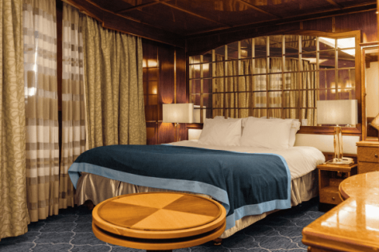  Averaging 21 square meters/226 square feet, these cabins are located on the Oceanus Deck. They feature a picture window (it may be covered during rough sea crossings), two wardrobes, and a King Size bed. Amenities include: en suite facilities, in-room safe, refrigerator, satellite telephone access, TV/VCR, individual temperature control, and hair dryer. | Classic Suite  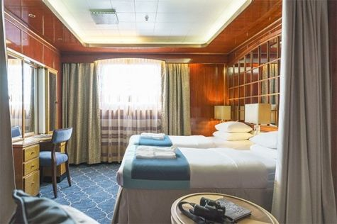  Averaging 21 square metres/226 square feet, these cabins are located on the Oceanus Deck. They feature a picture window, two wardrobes and a choice of either two twin beds or a King Size bed. Amenities include: en suite facilities, in-room safe, refrigerator, satellite telephone access, TV/DVD, individual temperature control and hair dryer.
Superior Suite  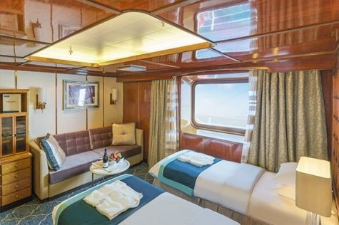  Superior Suites are located on the Club Deck. Averaging 20 square metres/ 215 square feet, these cabins feature two twin beds or a King Size bed. The picture window overlooks an outside walkway on the Club Deck. Amenities include: en suite facilities, walk-in closet or wardrobe, in-room safe, refrigerator, satellite telephone access, TV/DVD, individual temperature control, hair dryer. | Deluxe Suite  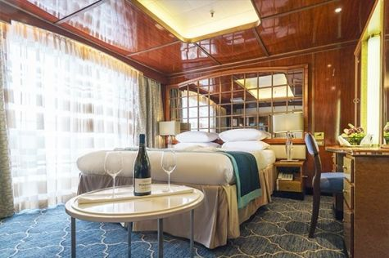  The Deluxe Suites with balconies are located on the Sports Deck. Averaging 24 square metres/ 258 square feet means plenty of room. Choose from either two twin beds or a King Size bed. A sliding glass door leads to a private balcony. These suites feature a walk-in closet or wardrobe. Amenities include en suite facilities, in-room safe, refrigerator, satellite telephone access, TV/DVD, individual temperature control, and a hair dryer.
Premium Suite  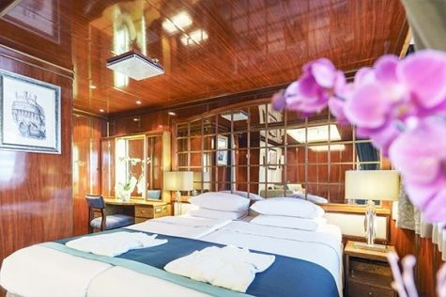  The Premium Suites are located on the Sun Deck. Averaging a generous 30 square metres/ 323 square feet, with two twin beds or a King Size bed. Access the private balcony by a sliding glass door. Amenities include: en suite facilities, lounge area, in-room safe, refrigerator, satellite telephone access, TV/DVD, individual temperature control, and hair dryer. | Owners Suite  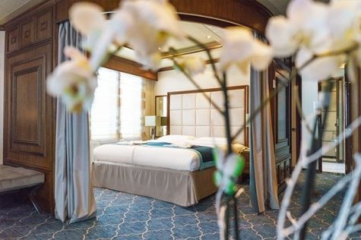  Super-spacious (63 square metres/ 678 square feet) elegant suite on the Sun Deck. Designed for entertaining, the Owner's Suite has a separate living room with game and meeting area. A BOSE stereo system provides background music, or watch videos on the HD plasma TV. Sliding glass doors lead to a private deck. Refresh in the jetted bathtub in en suite facilities. Slumber in the King Size bed. A sofa bed can accommodate a third person.

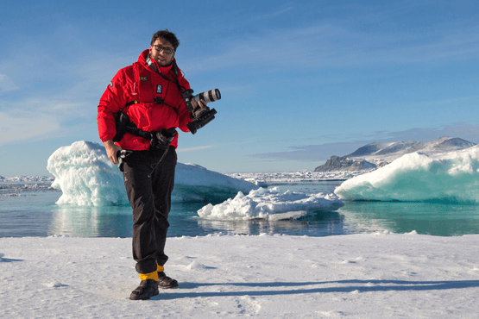 | Photography  Free option  The Polar Regions are perhaps the most photogenic on earth, with countless beautiful scenes presenting themselves every day. Endless expanses of ice, beaches crowded with seals or penguins, sunsets over unbroken horizons, starlit skies, and even the majestic northern lights – they all present fantastic photographic opportunities – and in order to make sure that you come home with some spectacular images we offer you the chance to learn and practice your photography alongside an experienced professional.  Our expert Photographer will be on hand to answer your questions and give advice, both in the form of on-board lectures and workshops on shore. Explore the key elements of photography in a fun and relaxed setting, with plenty of opportunities for questions and feedback. Learn how to see light in a new way and experiment with the techniques of composition and framing.

Rates
Triple Suite | Main Deck Suite | Single Suite | Classic Suite | Superior Suite | Deluxe Suite | Premium Suite | Owners Suite
US$ 6 795 | US$ 9 395 | US$ 13 995 | US$ 9 995 | US$ 10 195 | US$ 11 395 | US$ 12 495 | US$ 16 095
US$ 5 776 | US$ 7 986 | US$ 11 896 | US$ 8 496 | US$ 8 156 | US$ 9 116 | US$ 9 996 | US$ 12 876
* Super Early Bird discount (15% off on Triple, Main Deck, Single, and Classic Suites; 20% off on Superior, Deluxe, Premium, and Owner’s Suites) is available for new bookings confirmed by June 30, 2024.
Cruise rates are quoted per person. Sharing is available in Triple, Main Deck, Classic, and Superior Suites. If you prefer a cabin for yourself, the following categories are available with the single supplement: x1.7 for Main Deck, Classic, and Superior Suites; x2 for Deluxe, Premium, and Owner's Suite.

Rates Include  1 pre-voyage night on Day 1 in Radisson Blu Hotel, Edinburgh City Centre;  Group transfer to the ship on day of embarkation  Shipboard accommodation;  All meals on board throughout the voyage;  AECO fees and governmental taxes.  Tea and coffee station 24 hours daily;  All scheduled landings/excursions (subject to weather and ice conditions);  Leadership throughout the voyage by our experienced Expedition Leader and Expedition Team;  Branded Poseidon Expeditions parka;  Rubber boots for shore landings for the time of the cruise;  Welcome and Farewell cocktails;  All port fees;  Group transfer upon disembarkation;  Pre-departure materials;  Digital Voyage Log;  Wi-Fi on board. | Rates Do Not Include  Airfare;  Visa and passport fees (if applicable);  Luggage and trip cancellation insurance;  Fuel surcharge may be applied for all bookings;  Soft drinks and alcoholic beverages other than those for special events and celebrations;  Personal expenses such as laundry and telecommunication charges;  Mandatory Emergency Evacuation Insurance to a minimum benefit of US$ 200,000 per person;  Staff gratuities.
Itinerary, landings and all other activities during the cruise depend strongly on ice and weather conditions and are subject to the decisions of the Expedition Leader and the Captain of the vessel. Encounters with any mentioned wildlife cannot be guaranteed.

